**22**

**LAPORAN PRAKTIKUM**

**ALGORITMA DAN PEMROGRAMAN**

**Pertemuan Ke-3**



**Disusun Oleh :**

|  |  |
| --- | --- |
| **NAMA** | **: NANANG SETYAWAN** |
| **NIM** | **: 185410025** |
| **JURUSAN** | **: Teknik Informatika** |
| **JENJANG** | **: S1** |

**STMIK AKAKOM**

**YOGYAKARTA**

**2018**

**LAPORAN**

**ALGORITMA DAN PEMROGRAMAN**

**Pertemuan ke-3**

**PRAKTIK 1**

**1. 1st program to count total that must be paid by first person**

public class Tip01{

public static void main(String[]args){

double person1=10;

double total1=person1*(1+0.5+0.15);

System.out.println("Person 1:$"+total1);

}

}

Output:

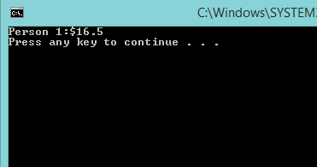

Explanation:

This program tell us to count total price that must be paid by first person

Tip01 is the name of class

Double is data type that use to decimal number.

Total1 is variable and 10 is value

Because value is 10 and use double, the output must be show a decimal number

Value of person1 is 10, so 10(1+0.5+0.15)=16.5

So tatal that must be paid by first person is 16.5

**2. 2nd program to count total that must be paid by each person**

public class Tip02{

public static void main(String[]args){

double person1=10;

double total1=person1*(1+0.05+0.15);

System.out.println("Person 1:$"+total1);

double person2=12;

double total2=person2+(person2*(0.05+0.15));

System.out.println("Person 2:$"+total2);

double person3=9;

double total3=person3+(person3*(0.05+0.15));

System.out.println("Person 3:$"+total3);

double person4=8;

double total4=person4*(1+0.05+0.15);

System.out.println("Person 4:$"+total4);

double person5=7;

double total5=person5*(1+0.05+0.15);

System.out.println("Person 5:$"+total5);

double person6=15;

double total6=person6*(1+0.05+0.15);

System.out.println("Person 6:$"+total6);

double person7=11;

double total7=person7*(1+0.05+0.15);

System.out.println("Person 7:$"+total7);

double person8=30;

double total8=person8*(1+0.05+0.15);

System.out.println("Person 8:$"+total8);

}

}

Output:

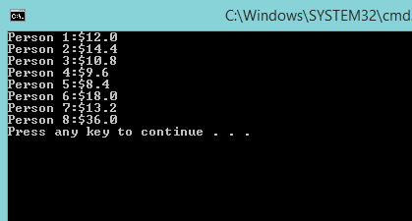

Explanation:

This program explain cost that must be paid by each person

This program is similar o first program, but the differences is in first program just use 1 person but in this program use 8 person, and we must count the total price each person.

We just input the value of person variable an multiply with (1+0.5+0.15) and the output is at picture above. From 1st person until 8th person we know total that they must be paid

**3. Using tax and tip variable**

public class Tip03{

public static void main(String[]args){

double tax=0.05;

double tip=0.15;

double person1=10;

double total1=person1+(person1*(tax+tip));

System.out.println("Person 1:$"+total1);

double person2=12;

double total2=person2+(person2*(tax+tip));

System.out.println("Person 2:$"+total2);

double person3=9;

double total3=person3+(person3*(tax+tip));

System.out.println("Person 3:$"+total3);

double person4=8;

double total4=person4*(1+tax+tip);

System.out.println("Person 4:$"+total4);

double person5=7;

double total5=person5*(1+tax+tip);

System.out.println("Person 5:$"+total5);

double person6=15;

double total6=person6*(1+tax+tip);

System.out.println("Person 6:$"+total6);

double person7=11;

double total7=person7*(1+tax+tip);

System.out.println("Person 7:$"+total7);

double person8=30;

double total8=person8*(1+tax+tip);

System.out.println("Person 8:$"+total8);

}

}

Output:

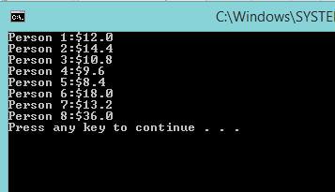

Explanation:

This program is to count price with tax and tip

This program is similar with previous program

It use 1st until 8th person

But the differences is the previous program use it value (1+0.5+0.15), but in this program its value change to variable.

We can see at this program it use variable and value, but in the main program it input variable tax and tip. But the output will still same because the value is same

**4. Using method**

public class Calculator{

//field

public double tax=0.05;

public double tip=0.15;

//methods

public double findTotal(double originalPrice){

double total=originalPrice+ (originalPrice*(tax+tip));

return total;

}

public static void main(String[]args){

Calculator calc = new Calculator();

System.out.println("Tax:"+calc.tax);

System.out.println("Tip:"+calc.tip);

System.out.println("Person 1:$"+calc.findTotal(10));

System.out.println("Person 2:$"+calc.findTotal(12));

System.out.println("Person 3:$"+calc.findTotal(9));

System.out.println("Person 4:$"+calc.findTotal(8));

System.out.println("Person 5:$"+calc.findTotal(7));

System.out.println("Person 6:$"+calc.findTotal(15));

System.out.println("Person 7:$"+calc.findTotal(11));

System.out.println("Person 8:$"+calc.findTotal(30));

}

}

Output:

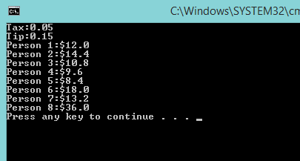

Explanation:

This program teach us to using method way

But program is still similar with previous program. The 1st person till 8th person value still same. It same use tax and tip

But the different is, in this program write all the value each person an after that the method will call them to find the price with tax and tip.

So all the person called to find total price by method

**5. Method with a parameter : change tip to 10%**

public class Calculator1{

//field

public double tax=0.05;

public double tip=0.15;

//methods

public double findTotal(double originalPrice){

double total=originalPrice+(originalPrice*(tax+tip));

return total;

}

public static void main(String[]args){

Calculator calc = new Calculator();

calc.tip=0.10;

System.out.println("Tax:"+calc.tax);

System.out.println("Tip:"+calc.tip);

System.out.println("Person 1:$"+calc.findTotal(10));

System.out.println("Person 2:$"+calc.findTotal(12));

System.out.println("Person 3:$"+calc.findTotal(9));

System.out.println("Person 4:$"+calc.findTotal(8));

System.out.println("Person 5:$"+calc.findTotal(7));

System.out.println("Person 6:$"+calc.findTotal(15));

System.out.println("Person 7:$"+calc.findTotal(11));

System.out.println("Person 8:$"+calc.findTotal(30));

}

}

Output:

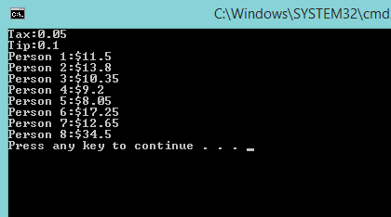

Explanation:

This program is using method but with parameter

It similar with previous program and the differences is this program using a parameter

The tip changed to 10%

So the 1st person until 8th person called by method to find total price if the value of tip changed to 10%

**6. Method without parameter : get a tip value**

public class Calculator2{

//field

public double tax=0.05;

public double tip=0.15;

//methods

public double getTip(){

return tip;

}

public double findTotal(double originalPrice){

double total=originalPrice*(1+tax+tip);

return total;

}

public static void main(String[]args){

Calculator2 calc=new Calculator2();

calc.tip=0.10;

System.out.println("Jumlah Tip(%):"+(calc.getTip()*100));

}

}

Output:

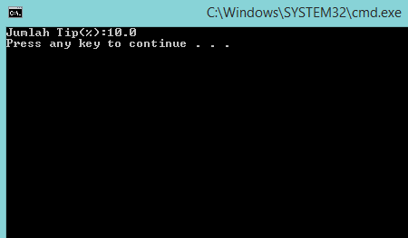

Eplanation:

This program is little different, we not more show price that must be paid in the output. Now asked to find the tip,s value. Its using method

I’m little confuse with this program, not too understand, but according to my opinion the tip that has 0.10 value multiply with 100 then shown in the output that the tip is 10

**7. Method without return value : print tip**

public class Calculator3{

//field

public double tax=0.05;

public double tip=0.15;

//methods

public double getTip(){

return tip;

}

public void printTip(){

System.out.println("Jumlah Tip:"+tip);

}

public double findTotal(double originalPrice){

double total=originalPrice*(1+tax+tip);

return total;

}

public static void main(String[]args){

Calculator3 calc=new Calculator3();

calc.printTip();

}

}

Output:

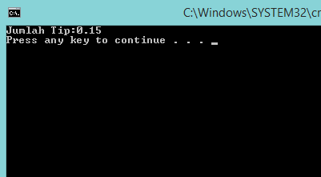

Explanation:

This program use method with return value and we asked to print tip

We must show total tip

We know the tax is 0.05 and the tip is 0.15 but in the output System.out.println total tip : tip. So the output show it that toatal tip is 0.05

**8. Method with return value : getTip method**

public class Calculator4{

//field

public double tax=0.05;

public double tip=0.15;

//methods

public double getTip(){

return tip;

}

public void printTip(){

System.out.println("Jumlah Tip:"+tip);

}

public double findTotal(double originalPrice){

double total=originalPrice*(1+tax+tip);

return total;

}

public static void main(String[]args){

Calculator4 calc=new Calculator4();

double tip=calc.getTip();

System.out.println("Jumlah Tip:"+tip);

}

}

Ouput:

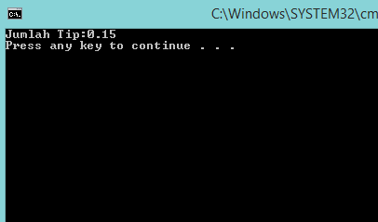

Explanation:

This program use method with return value and use getTip

Its so similar from previous program

Its output same that show total tip

The differences is previous program use print tip, and this program use getTip. And I didn’t really know the differences between printTip and GetTip

All its code are same, its output same. Just that 2 word make it different

**PRAKTIK 2**

**1. Using/import scanner class package**

public class Calculator5{

//field

public double tax=0.05;

public double tip=0.15;

//methods

public double findTotal(double originalPrice){

double total=originalPrice*(1+tax+tip);

return total;

}

public static void main(String[]args){

java.util.Scanner keyboard=new java.util.Scanner(System.in);

Calculator5 calc=new Calculator5();

calc.tip=0.10;

System.out.println("Tax:"+calc.tax);

System.out.println("Tip:"+calc.tip);

System.out.println("Enter the originalPrice:");

Double originalPrice=keyboard.nextDouble();

System.out.println("Person :$"+calc.findTotal(originalPrice));

}

}

Output:

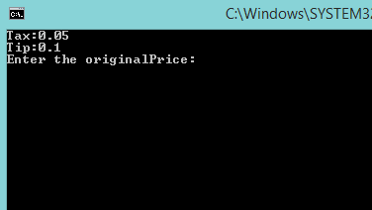

Explanation:

This program using/import scanner package

Actually this is my favorite when we use scanner in java, so we can input number or String in output

Tax variable is 0.5 and tip has 0.15 and it will calculate. But this program not complete because in the output tax and tip value are shown and we asked to input original price. When we input it the output will closed because the code end at that word.

Keyboard.nextDouble is used to input number or String in output box or command prompt.

**2. Import package, can be write below**

import java.util.Scanner;

public class TestCalculator{

public static void main(String[]args){

Scanner keyboard=new Scanner(System.in);

Calculator calc=new Calculator();

System.out.println("Enter the originalPrice:");

Double originalPrice=keyboard.nextDouble();

System.out.println("Person:$"+calc.findTotal(originalPrice));

}

}

Output:

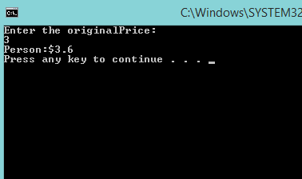

Explanation:

This program asked to show price per-person

We can say this program is the next from previous program

In previous program the output end when we input the original price but in this program its show the price per person if we input the original price

**LATIHAN**

**1. Make program to show nim, name, major, ipk from keyboard input**

import java.util.Scanner;

public class Nanang{

public static void main(String[]args){

int NIM;

String Nama, Jurusan;

double IPK;

Scanner keyboard=new Scanner(System.in);

System.out.println("Masukkan Nama");

Nama= keyboard.next();

System.out.println("Masukkan NIM");

NIM= keyboard.nextInt();

System.out.println("Masukkan Jurusan");

Jurusan= keyboard.next();

System.out.println("Masukkan IPK");

IPK= keyboard.nextDouble();

System.out.println("===========================");

System.out.println(" Nama:"+Nama );

System.out.println(" NIM:"+NIM );

System.out.println(" Jurusan:"+Jurusan );

System.out.println(" IPK:"+IPK );

System.out.println("===========================");

}

}

Output:

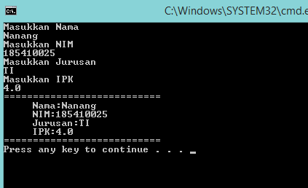

Explanation:

In this program we asked to show a nim, name, major and ipk but must using java.util.Scanner or keyboard input

We use int for nim because nim value is integer

We use String for name and major because its value is text

And we use dauble for ipk because ipk value is decimal number

Scanner keyboard=new Scanner(System.in) using if we want input keyboard in output display.

If we want to write name we use Nama=keyboard.next();

For nim, NIM=keyboard.nextInt(), it use nextInt because nim value is integer

To input major, same with name input.

And for ipk, we use IPK=keyboard.nextDouble();. It use nextDouble because IPK’s value is a decimal number.

So if we run it we will asked to input name, nim, major and IPK

After we write it, it will show our name, nim, major and ipk

**CONCLUTION**

After this practice we know to make a program and its purpose little by little. We are given many similar program, so that we can see the differences each program and focus to learn it. And we know to input keyboard in command prompt with scanner, so we know direct input by system.out.println and we know input keyboard in output program